**DAILY ONLINE ACTIVITIES SUMMARY**

|  |  |  |  |  |  |  |  |  |
| --- | --- | --- | --- | --- | --- | --- | --- | --- |
| **Date:** | **13/06/2020** | | | | | **Name:** | **Chandana Patil** | |
| **Sem & Sec** | **6th Sem and A Sec** | | | | | **USN:** | **4AL17CS020** | |
| **Online Test Summary** | | | | | | | | |
| **Subject** | | **PAP-IV** | | | | | | |
| **Max. Marks** | | **30** | | **Score** | | | **29** | |
| **Certification Course Summary** | | | | | | | | |
| **Course** | Cloud Foundation | | | | | | | |
| **Certificate Provider** | | | **Greatlearning** | | **Duration** | | | **6 Hours** |
| **Coding Challenges** | | | | | | | | |
| **Problem Statement:**  **1.** Python Program to print the pattern.  **2.** Write a Java Program to determine whether a given matrix is a sparse matrix.  **3.** Write a C program to calculate Electricity Bill. | | | | | | | | |
| **Status: Completed** | | | | | | | | |
| **Uploaded the report in Github** | | | | | **yes** | | | |
| **If yes Repository name** | | | | | **https://github.com/chandanapatil/OnlineCourse.git** | | | |
| **Uploaded the report in slack** | | | | | **Yes** | | | |

**Online Test:**

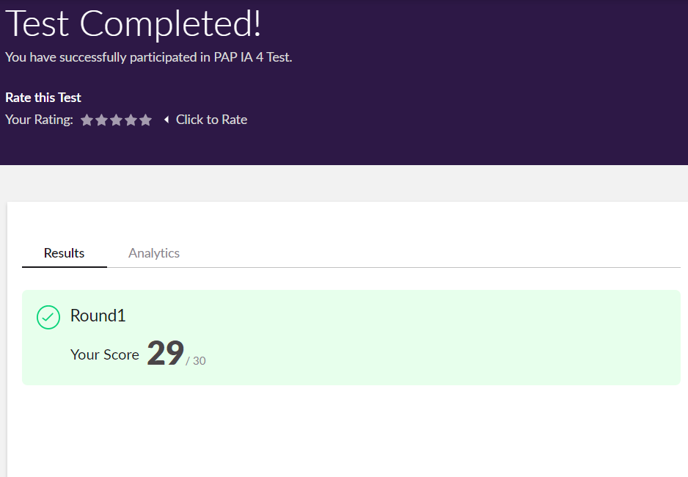

**Certification:**

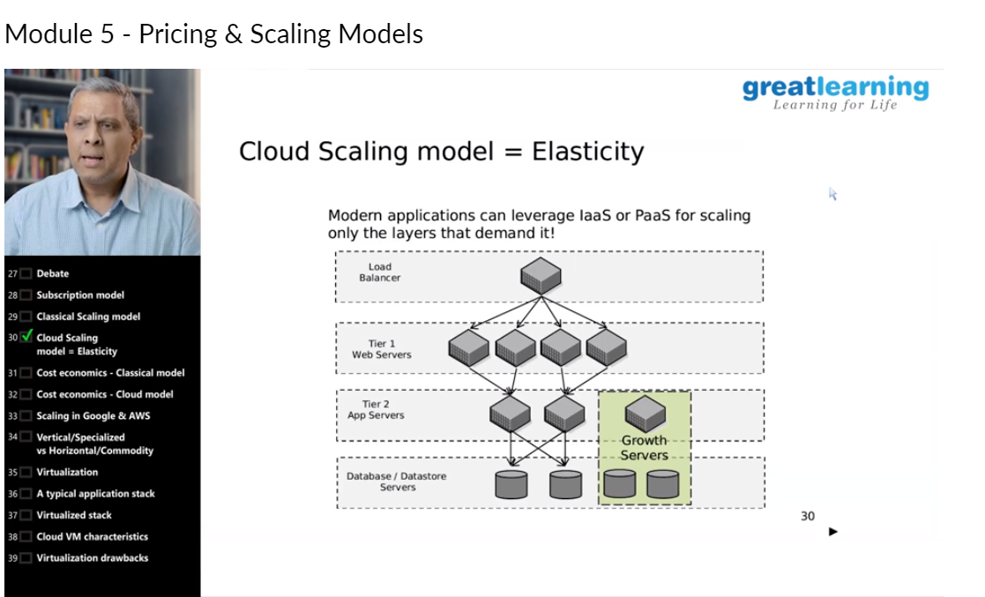

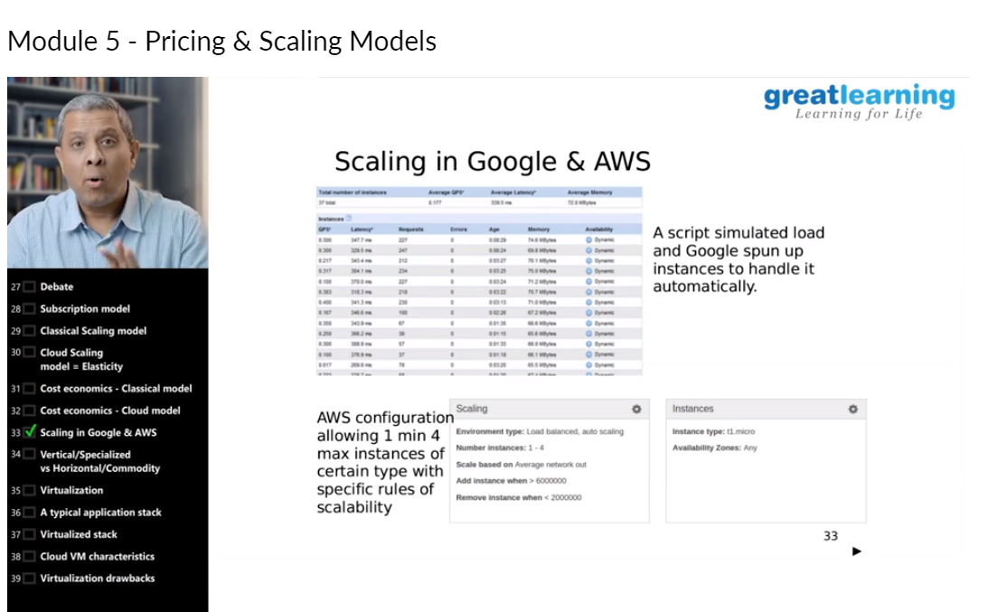

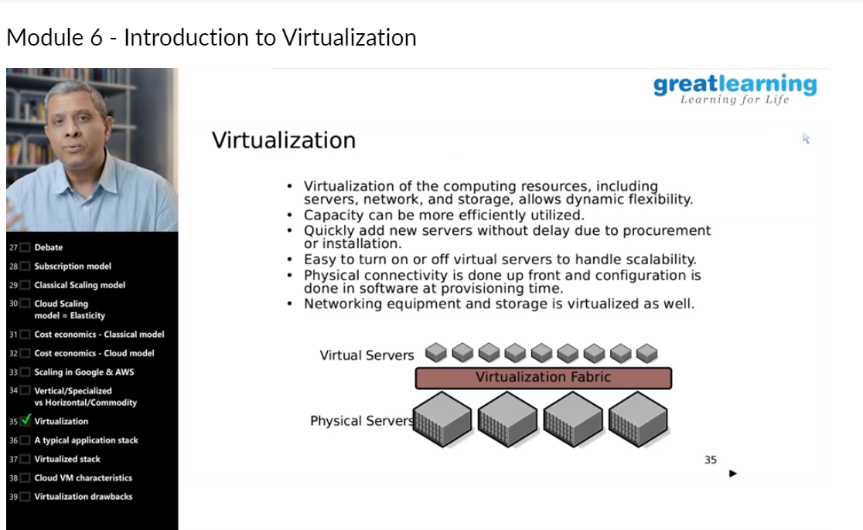

**OnlineCoding:**

**Prog1:** Python Program to print the pattern.

Description:

Input: Number of rows is 5

Output Pattern is:

A

B C

D E F

G H I J

K L M N O

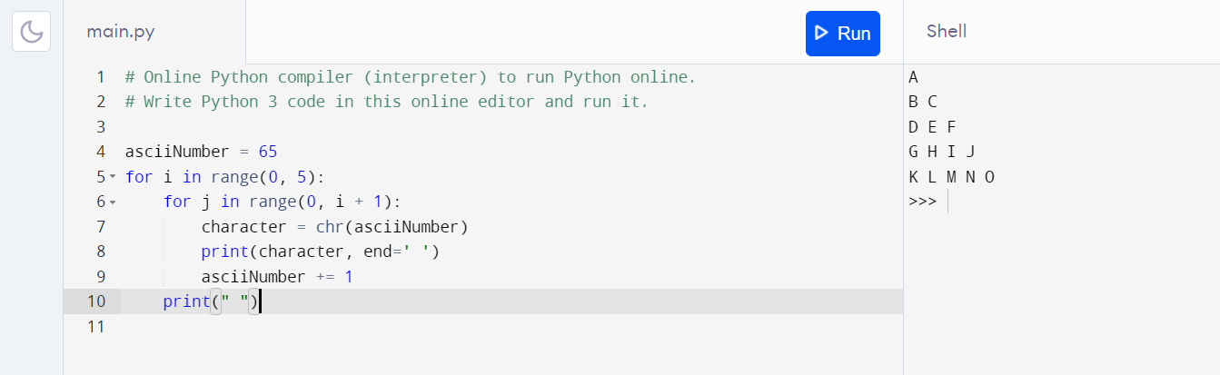

**Prog 2:** Write a Java Program to determine whether a given matrix is a sparse matrix.

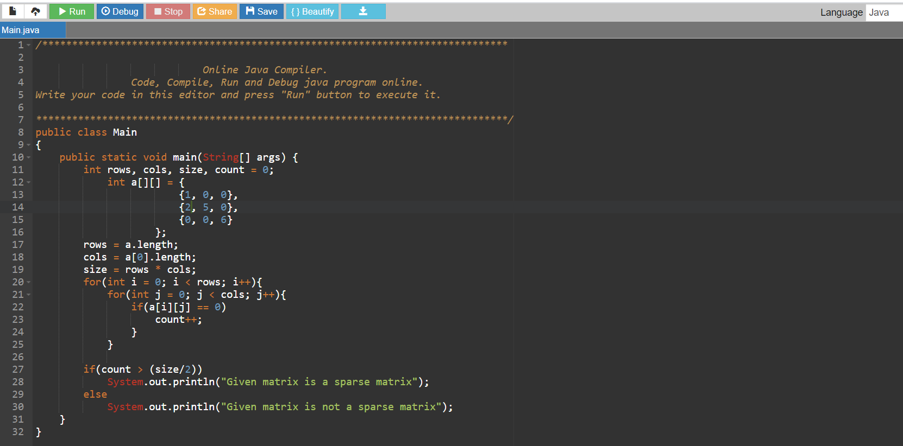

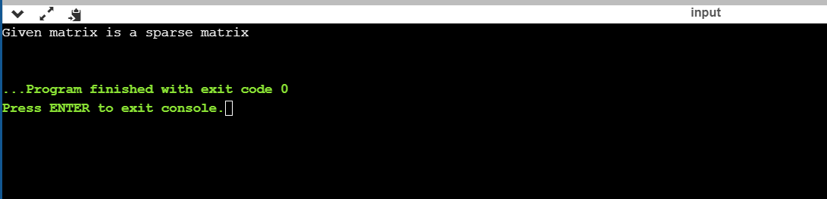

**Prog 3:** Write a C program to calculate Electricity Bill.

Description: Given an integer U denoting the amount of KWh units of electricity consumed, the task is to calculate the electricity bill with the help of the below charges:

• 1 to 100 units – Rs. 10/- Per Unit

• 100 to 200 units – Rs. 15/- Per Unit

• 200 to 300 units – Rs. 20/- Per Unit

• above 300 units – Rs. 25/- Per Unit

